**React Tutorials**

**To install**

Npm i –g create-react-app

**Syntax to start the react program**

npx create-react-app my-app

cd my-app

npm start

**What is JSX?**

JSX is javascript xml. A way of writing html code in js.

**Component in React**

Component is a custom html element.

A Component in react is just a JS function.

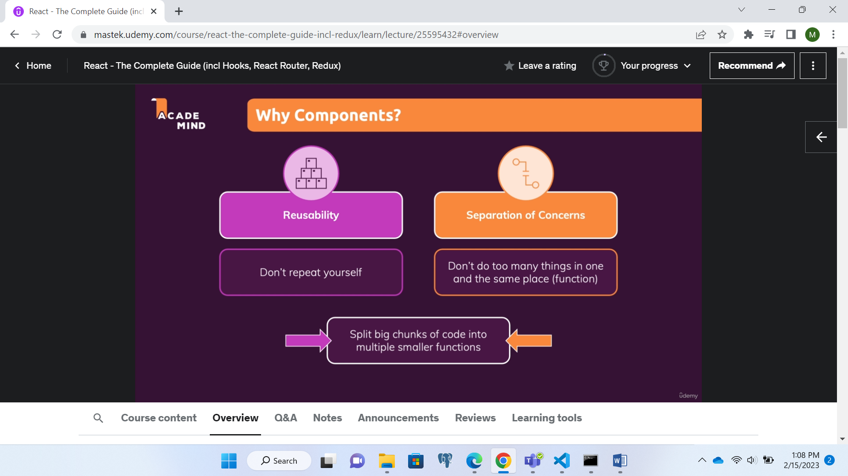

**Passing JS data to JSX**

Using ‘{}’ to pass JS data

function ExpenseItem() {

    const expenseDate = new Date(2021, 2, 28);

    const expenseTitle = "Car Insurance";

    const expenseAmount = 234.33;

  return (

    <div className="expense-item">

      <div>{expenseDate.toISOString()}</div>

      <div className="expense-item__description">

        <h2>{expenseTitle}</h2>

      </div>

      <div className="expense-item__price">{expenseAmount}</div>

    </div>

  );

}

**Using Props to send JS data to JSX**

E.g

Using custom html element

<ExpenseItem title={expenses[0].title} amount={expenses[0].amount} date={expenses[0].date}></ExpenseItem>

Custom element creation

function ExpenseItem(props) {

  return (

    <div className="expense-item">

      <div>{props.date.toISOString()}</div>

      <div className="expense-item__description">

        <h2>{props.title}</h2>

      </div>

      <div className="expense-item__price">${props.amount}</div>

    </div>

  );

}

JSX code converts to React code

